The Ultimate Irresistible Offer Formula
Say these words and people will buy anything from you

Nicolas Cole
and
Dickie Bush
Jun 12, 2024

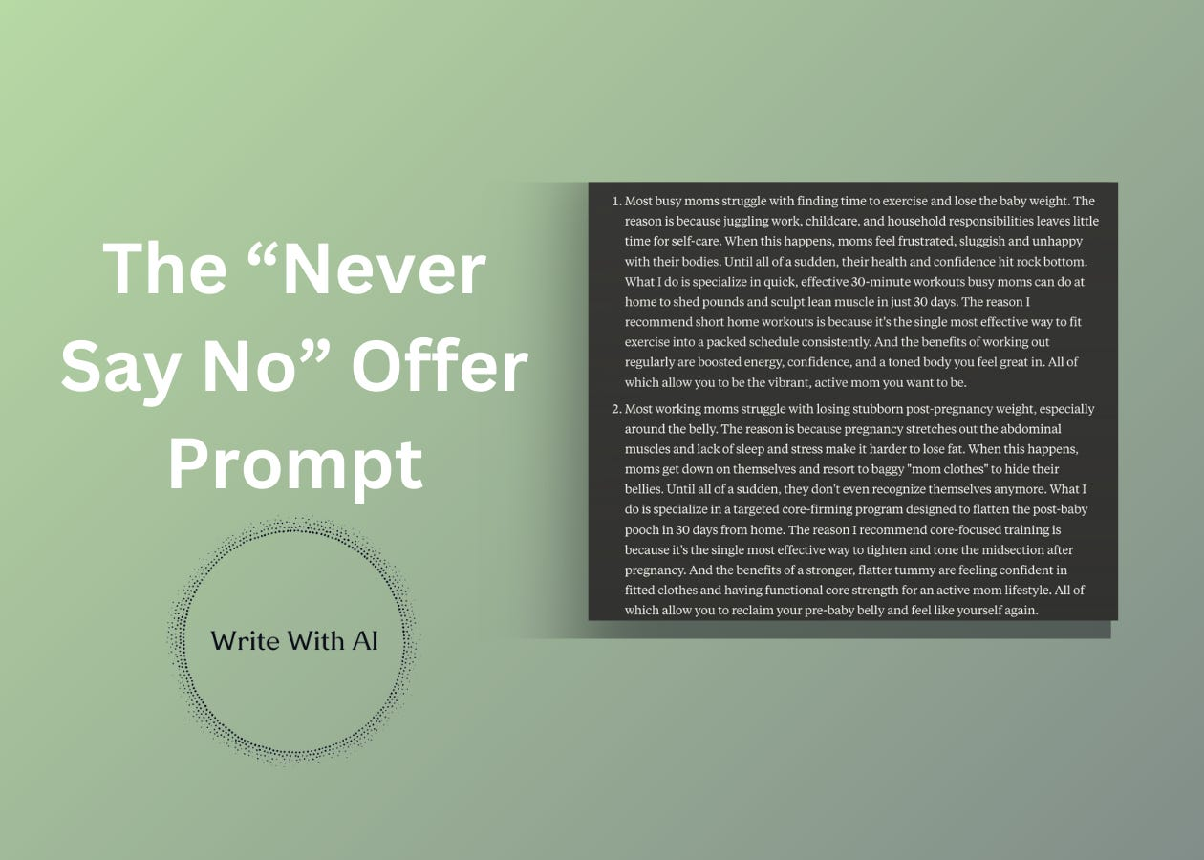

Hey there, Digital Writers!
If your product or service isn't selling, it's not because there isn't demand or you don't have enough credibility.
It's because you aren't packaging it as an irresistible offer.
Today, I'm going to give you my irresistible offer script to make any product or service impossible to say no to. If you can understand the two formulas I'm about to share with you, you'll be able to sell any product or service and start landing high-ticket clients today.
I know this script works because this is the exact same script we have writers using in our Premium Ghost Writing Academy to land $5,000 clients, even complete beginners who have never written on the internet before.
For example, take Khalid:
- He’d never written even a single tweet.
- He’d never sold a client.
- He’d never even taken a sales call or worked as a freelancer before.
Now, using this simple script, he's making $16,000 per month as a ghostwriter while working his full-time job.
Not bad for a side hustle.
Before I share the first formula with you, I need to tell you something.
“Everything you have ever heard or been taught about marketing and sales is completely backwards.”
And I can prove it with a simple, silly example:
The “Toilet Paper” Test.
If I asked you out of the blue, "Do you want to buy a roll of toilet paper?" you'd probably say no and then call me a walnut for wasting your time.
But…



If you were stuck on the side of the road with a flat tire and a raging stomach ache and no bathroom for 100 miles, and I pulled up and asked, "Do you want to buy a roll of toilet paper?" Not only would you say yes, but you'd probably shower me with admiration, say thank you a hundred times, and pay me a premium for it.
So what's the moral of the story?
Write this down on a notecard and put it on your desk:
“The customer has to care about the problem before they can care about the solution.”
I have always found that whenever someone is struggling to sell any product or service, 99.9% of the time it's because they only talk about the solution and spend almost no time educating the person on the problem.
And the person can't care about the solution until they care about the problem.
So how do we get the customer to care about the problem?
Very simple.
The Problem Formula
We have to educate them on four things:
- Specific Problem
- Reason Why
- Consequence of Problem
- Ultimate Negative Outcome
Let's walk through each one.
First, you have to demonstrate to the customer you know what problem they have. Trust has nothing to do with credibility - trust is about understanding. If I can demonstrate that I understand your problem, you will trust me.
Second, you reinforce this trust by educating the customer on the reason why this problem happens in the first place. Notice you aren't actually selling them - you're educating them. "You have this problem, here's the reason why."
Third, you make them feel the pain of their existing problem. What consequence are they experiencing as a result of this problem?
And fourth, you ground them in the cost of inaction. You have a problem, now you know the reason why it's happening, you can feel the pain of that problem in your life, and if you don't solve it, here's the ultimate negative outcome you should expect to happen in the not-so-distant future.
Here's an easy example:
- Specific Problem: You have trouble sleeping at night.
- Reason Why: The reason is because your body temperature is too hot, and when your body gets too hot, you wake up.
- Consequence of Problem: When you can't sleep through the night, your deep sleep gets disrupted. You wake up exhausted and spend the whole day with brain fog.
- Ultimate Negative Outcome: And when you are constantly exhausted, not only does your productivity and general happiness nose dive, but lack of sleep can lead to other chronic health problems like heart disease, kidney disease, diabetes, stroke, obesity, and depression.
Now what is the first thing your brain thinks to ask next? "Wow, how do I fix it?"
Problem first, solution second.
This is the first half of the irresistible offer script.



The Solution Formula
Once you've educated them on the specific problem, now it's time to tell them how to fix it.
Here's the second formula:
- Specific Solution
- Reason Why
- Benefits of Solution
- Ultimate Positive Outcome
So let's stick with our sleep example:
- Specific Solution: The solution to sleep through the night and never wake up hot again - you need a temperature controlled mattress.
- Reason Why: The reason why is because a temperature controlled mattress allows you to stay cool all night long.
- Benefits of Solution: When you stay cool all night long, your heart rate drops, you get deeper and higher quality sleep, and you wake up every morning feeling rested.
- Ultimate Positive Outcome: And when you wake up every morning fully rested, not only will you be more productive and happier in your life, but deep sleep also strengthens your memory and immune system, keeping you healthy.
Notice how I'm not naming a brand or a specific product in the solution.
I'm not saying "buy my product or service." All I'm doing is educating the prospect on the category of solution they need to buy into the idea of a temperature controlled mattress first. Because if they do, they will naturally assume that (a) I can give it to them, and (b) I am the best person to give it to them, because I was the one who educated them on the problem and the solution.
Now let's tie what we've learned into the full irresistible offer script that's going to land you the loyal customers and high-ticket clients you want.
The Full Ultimate Offer Formula
- Most {Specific Audience} struggle with {Specific Problem}.
- The reason is because {Specific, Tangible Reason Why}.
- When this happens, {Specific Consequence Of Problem}.
- Until all of a sudden, {Ultimate Negative Outcome}.
- What I do is I specialize in {Specific Service} to {Specific Desirable Outcome}.
- The reason why I recommend {Specific Service} is because it’s the single most effective way to {Solve Specific Problem}.
- And the benefit of {Solving Specific Problem} is {Specific Benefits}.
- All of which allow you to {Ultimate Positive Outcome}.
All you have to do is fill in the Mad Libs above, and write out your Irresistible Offer script.
And if, at any point, you feel like you don’t know how to fill one of these in… that means you have some work to do! Either by experimenting on yourself, or talking to people you want to help, offering to do some work for free, and better understanding what they need help with in their lives & businesses.
Or you can…
Write An Irresistible Offer With The “Never Say No” Prompt
I recommend using Claude for this prompt.
Claude does a better job filling the “Mad-Libs” with problems and solutions like a human. But, you can use ChatGPT, Gemini, or any other LLM that knows how to interpret prompts.
All you have to do is give Claude the context for your product / service, your target customer, and the problem you solve.
For example:
Generate 3 irresistible offer ideas for a 30-day at-home fitness program that helps busy moms lose weight and tone up.

Focus on the key problems, benefits, and desired outcome.

Irresistible Offer:

Most {Specific Audience} struggle with {Specific Problem}.
The reason is because {Specific, Tangible Reason Why}.
When this happens, {Specific Consequence Of Problem}.
Until all of a sudden, {Ultimate Negative Outcome}.
What I do is I specialize in {Specific Service} to {Specific Desirable Outcome}.
The reason why I recommend {Specific Service} is because it’s the single most effective way to {Solve Specific Problem}.
And the benefit of {Solving Specific Problem} is {Specific Benefits}.
All of which allow you to {Ultimate Positive Outcome}.
Sample output:

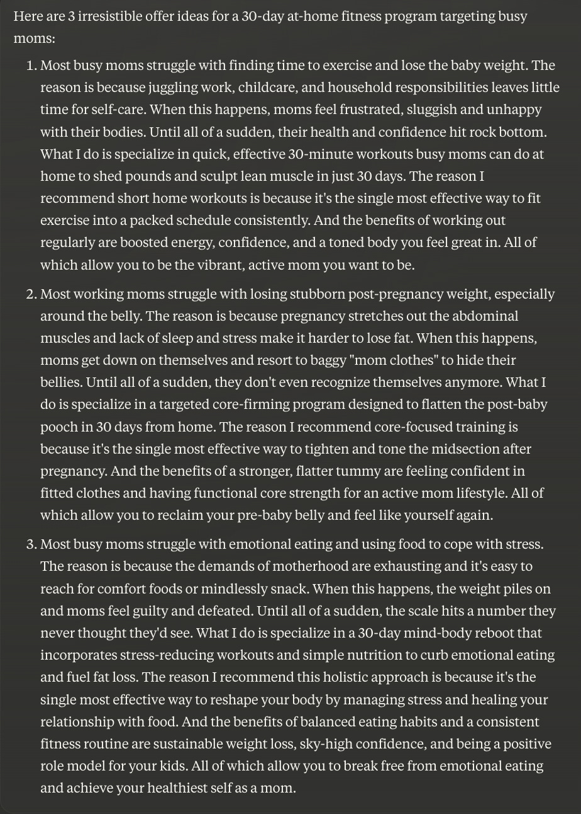

Review the generated offers.
Choose the one you like best (and the one you can deliver on).
A couple tips for using this prompt:
- If you aren’t sure what product or service to offer, feed Claude your target audience and it will generate 3 different offers. For example, prompting Claude with “busy moms” results in an offer for a wellness retreat, a meal planning service, and a DFY wash and fold laundry service.
- Or let’s say you have a product or service idea, but you don’t know your target audience. Claude will generate different audiences who might be interested in the offer. A wash and fold laundry service could be a fit for busy moms, but it could also work for college students or traveling professionals.
Dial the specificity for your context up and down and let Claude fill in the gaps to refine your offer.
Here’s the prompt template:
Generate 3 irresistible offer ideas for a {Product/Service} that helps {Target Audience} who want to {Avoid Problem or Acheive Outcome}.

Focus on the key problems, benefits, and desired outcome.

Irresistible Offer:

Most {Specific Audience} struggle with {Specific Problem}.
The reason is because {Specific, Tangible Reason Why}.
When this happens, {Specific Consequence Of Problem}.
Until all of a sudden, {Ultimate Negative Outcome}.
What I do is I specialize in {Specific Service} to {Specific Desirable Outcome}.
The reason why I recommend {Specific Service} is because it’s the single most effective way to {Solve Specific Problem}.
And the benefit of {Solving Specific Problem} is {Specific Benefits}.
All of which allow you to {Ultimate Positive Outcome}.
Finally, if Claude is responding with generic problems and solutions, you can follow up with another prompt directing it to “Be more specific and tangible” or to “Think about the common fears, thoughts, or misconceptions the {audience} has about the {problem}.”
Both of these follow up prompts will guide AI to get more specific.
That’s it.
I have used this irresistible offer script over and over again in all of my businesses, and I have mentored hundreds of writers in our Premium Ghostwriting Academy on how to use the same script for any ghostwriting service. Now it’s yours!
So, use this to get started and let us know how it goes.
Chat soon,

